**CODING CONTEST 1**

**727721EUIT124**

**03/05/2023 RAJPAL B**

**2023_SKCET_Cloud_CC1**

**Time:30 minutes Marks:17**

**Q2. Create an IAM group called 'Network-L1-Team' with 'AmazonVPCReadOnlyAccess' and ‘AWSNetworkManagerReadOnlyAccess' policies, then add an IAM user called 'Network-L1-User1' to the group.**

**The name of the IAM group should be 'Network-L1-Team'.(4 Marks)**

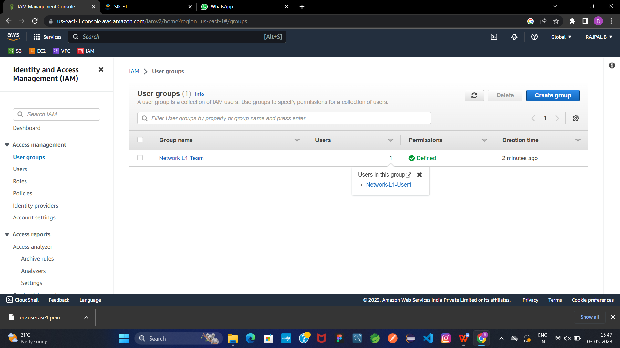

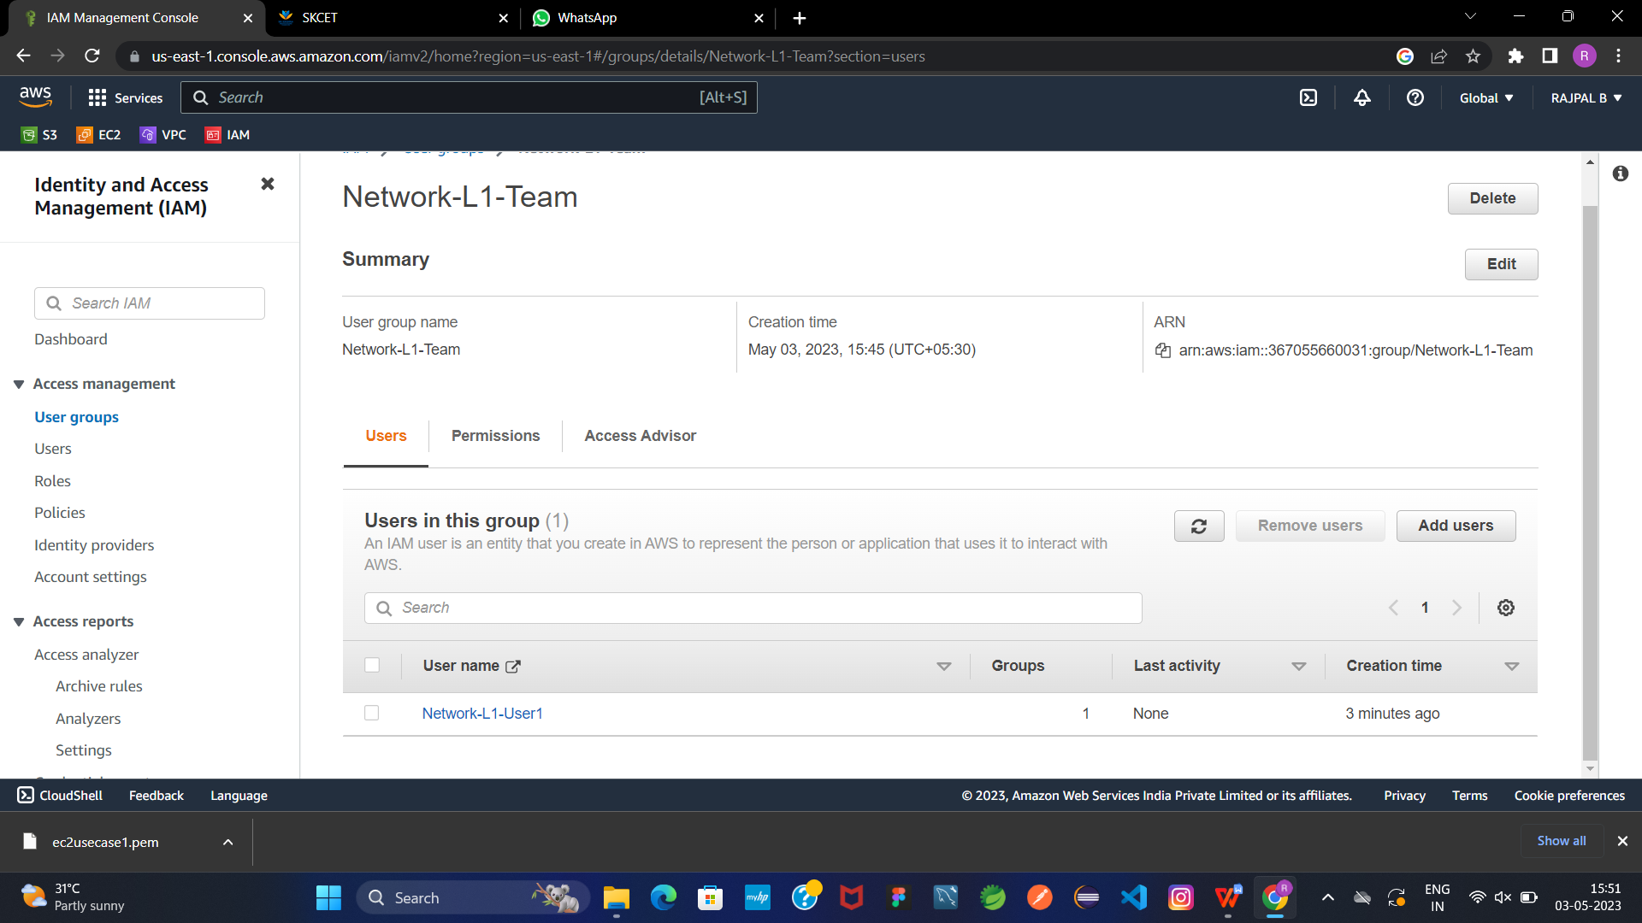

**The name of the IAM user should be 'Network-L1-User1'.(4 Marks)**

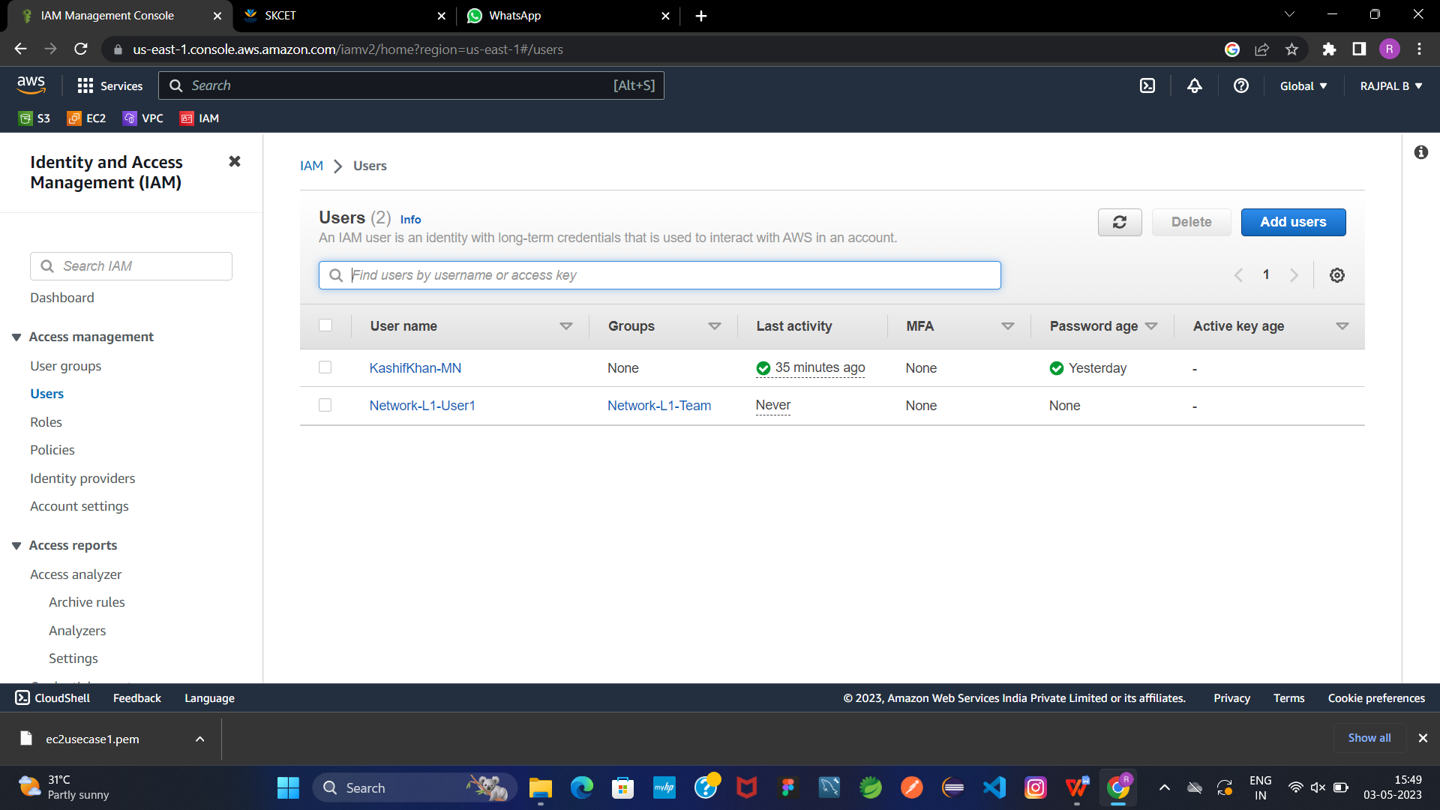

**The 'AmazonVPCReadOnlyAccess' policy should be attached.(4 Marks)**

**The 'AWSNetworkManagerReadOnlyAccess' policy should be attached.(5Marks)**

